1. Objective of whole project.

Compare MADGE data to other machine learning algorithms like SVM and neural networks. Accuracy and speed will be the two most optimized features, with accuracy without overfitting as the most interesting piece to explore.

1. What was implemented last week.

Ran accuracy tests on two datasets: abalone and iris petal data.

A cursory glance at accuracies on Iris petal data online match with the highest accuracies. I Will try to find an academic paper that analyzes this dataset. The abalone dataset also had a higher accuracy than found on this paper:

<http://users.cecs.anu.edu.au/~Tom.Gedeon/conf/ABCs2018/paper/ABCs2018_paper_35.pdf>

A runtime comparison should be made between the two methods.

1. Plans for upcoming week.

Write up a paragraph comparing the two methods between the paper found and my work similar to how it would be written in a paper.

Find another dataset and literature that can show our method is superior.

1. Objective of whole project.

Compare MADGE data to other machine learning algorithms like SVM and neural networks. Accuracy and speed will be the two most optimized features, with accuracy without overfitting as the most interesting piece to explore.

1. What was implemented last week.

Instead of trying to find an optimal sigma based on the range of the data, the training data was normalized to a 1x1 square range, as was each point.

The method is presented as follows.

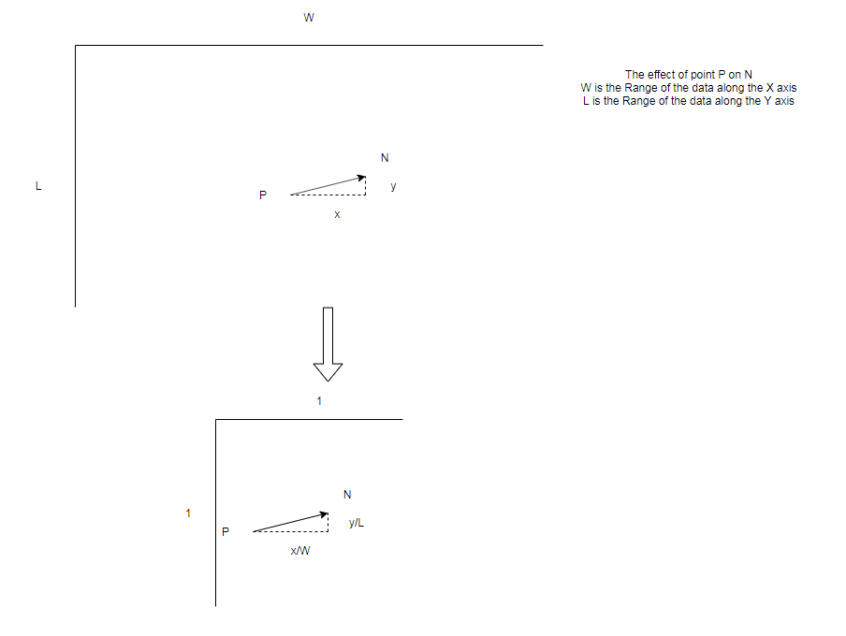

A sigma of ~0.02 was found to be the most optimal sigma (accuracy ~99%). Based on the range of the data being [1, 1], this sigma is about 2% of the range of each dimension. This is still an empirically tested value. There might be an absolute maximum. Theoretically, based on the range of the normalized data, there should be an empirical absolute maximum that we can determine.

1. Plans for upcoming week.

Find an optimal empirical sigma for stretched spiral data.

See if this optimal empirical sigma is the same for other stretched data. It should, since the range of the data has been normalized.